**Project Instructions:**

Write three SQL queries to answer the following questions:

1. What are the most popular transport types, measured by the total number of journeys? The output should contain two columns, 1) JOURNEY_TYPE and 2) TOTAL_JOURNEYS_MILLIONS, and be sorted by the second column in descending order. Save the query as most_popular_transport_types.
2. Which five months and years were the most popular for the Emirates Airline? Return an output containing MONTH, YEAR, and JOURNEYS_MILLIONS, with the latter rounded to two decimal places and aliased as ROUNDED_JOURNEYS_MILLIONS. Exclude null values and save the result as emirates_airline_popularity.
3. Find the five years with the lowest volume of Underground & DLR journeys, saving as least_popular_years_tube. The results should contain the columns YEAR, JOURNEY_TYPE, and TOTAL_JOURNEYS_MILLIONS.

Three SQL cells have been created for you in the workbook. To access the Snowflake database, you will need to select data using the syntax FROM TFL.JOURNEYS (ensure you use upper-case).

**Note**: Please also ensure that you do not change the names of the DataFrames that the three query results will be saved as - creating new cells in the workbook will rename the DataFrame (see image below). Make sure that your final solutions use the names provided: most_popular_transport_types, emirates_airline_popularity, and least_popular_years_tube.

**1 >>>>**

SELECT JOURNEY_TYPE, SUM(JOURNEYS_MILLIONS) as TOTAL_JOURNEYS_MILLIONS

FROM TFL.JOURNEYS

GROUP BY JOURNEY_TYPE

ORDER BY TOTAL_JOURNEYS_MILLIONS DESC;

**2 >>>>**

SELECT MONTH, YEAR, ROUND(JOURNEYS_MILLIONS,2) as ROUNDED_JOURNEYS_MILLIONS

FROM TFL.JOURNEYS

WHERE JOURNEY_TYPE = 'Emirates Airline' AND ROUNDED_JOURNEYS_MILLIONS IS NOT NULL

GROUP BY MONTH,YEAR,ROUNDED_JOURNEYS_MILLIONS

ORDER BY ROUNDED_JOURNEYS_MILLIONS DESC

LIMIT 5;

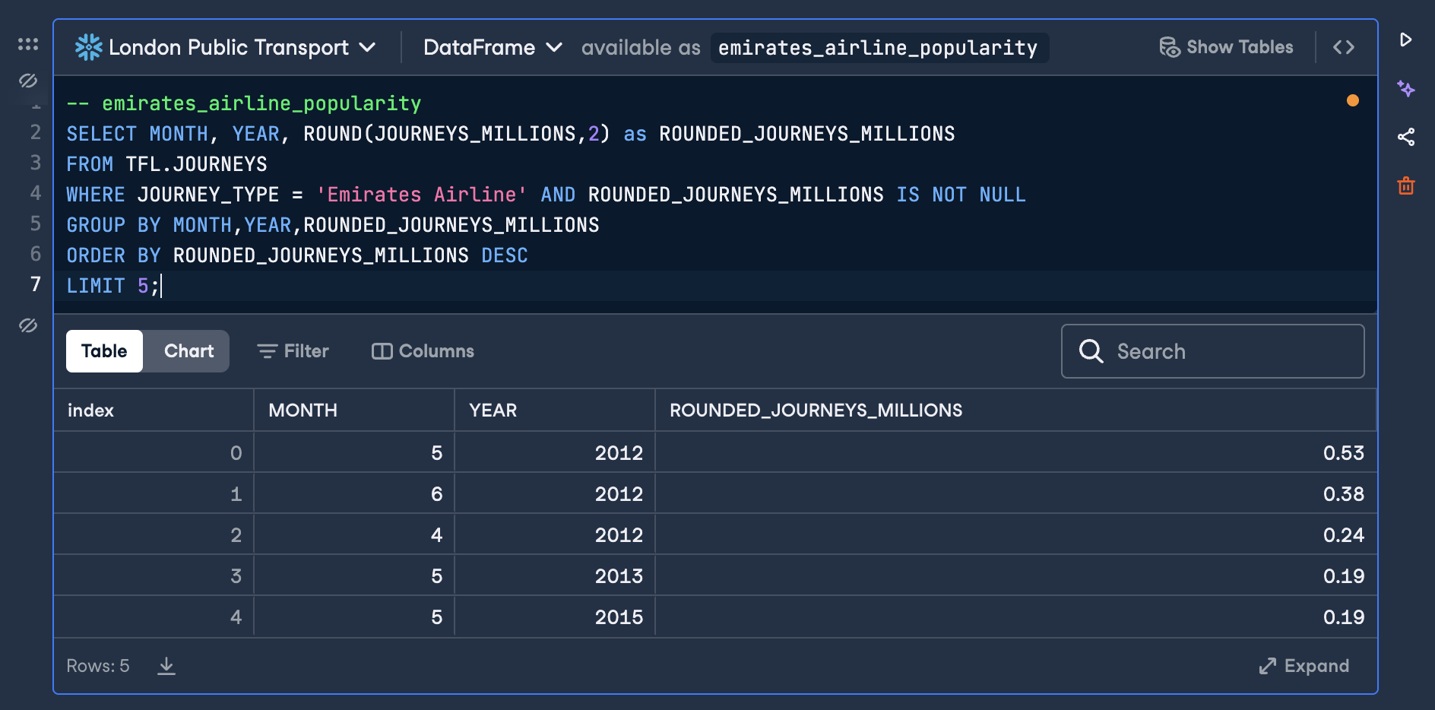

**3 >>>>**

SELECT YEAR, JOURNEY_TYPE, SUM(JOURNEYS_MILLIONS) as TOTAL_JOURNEYS_MILLIONS

FROM TFL.JOURNEYS

WHERE JOURNEY_TYPE = 'Underground & DLR'

GROUP BY YEAR, JOURNEY_TYPE

ORDER BY TOTAL_JOURNEYS_MILLIONS

LIMIT 5;

